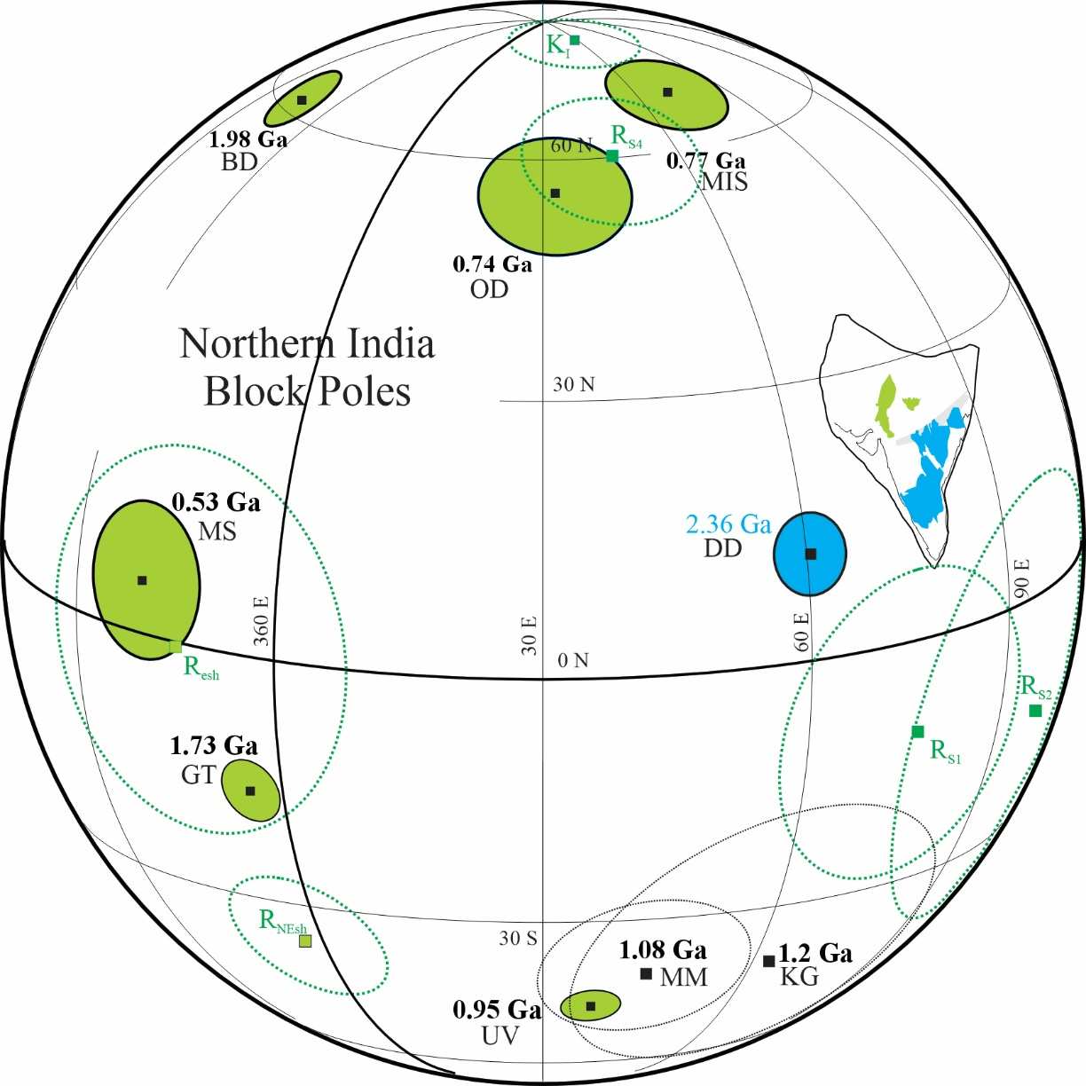
Supplementary Figure 1: Grand Mean paleomagnetic poles from the Northern Indian block (R ≥ 4; green solid circles). Blue-shaded pole (DD) is the mean 2.367 Ga pole from the Dharwar craton for comparison. Undated VGP’s reported by Radhakrishna et al. (2013a) are shown as dashed green A95 circles. These VGP’s are R_{S1} (Steep 1), R_{S2} (Steep 2), R_{S4} (Steep 4), R_{NEsh} (NE-shallow, R_{esh} (E-shallow) as found in Table 1 of Radhakrisnha et al. (2013a); K_{I}=Kaimur intermediate direction (this paper and Poornachandra-Rao et al., 2005).Unshaded dashed ovals are the mean pole from the Majhgawan kimberlite and Mahoba dykes (1.08 Ga, MM) and the VGP from the Kaimur formation (~1.2 Ga, K_{III}). Note that some poles are plotted as ‘anti-poles’ to fit all on a single hemisphere. Other Abbreviations: BD=Bundelkhand dykes, GT=Gwalior Traps, UV=Upper Vindhyan, MI=Malani Igneous Province, OD=Orchha dykes, MS=Marwar Supergroup.

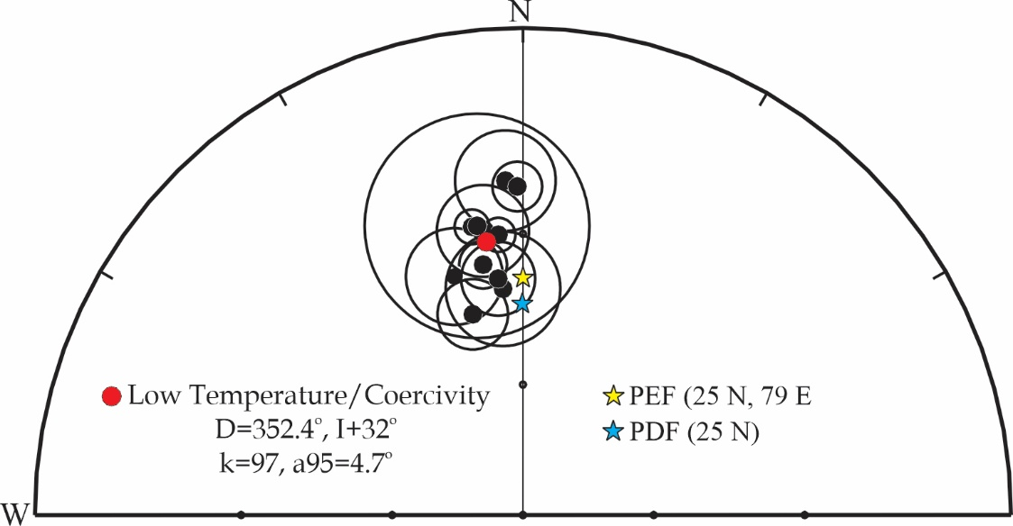
Supplementary Figure 2: Low-temperature/coercivity directions from Lower Vindhyan rocks (mean red circle) compared to the present dipole field (blue star) and the present Earth’s field (yellow star).

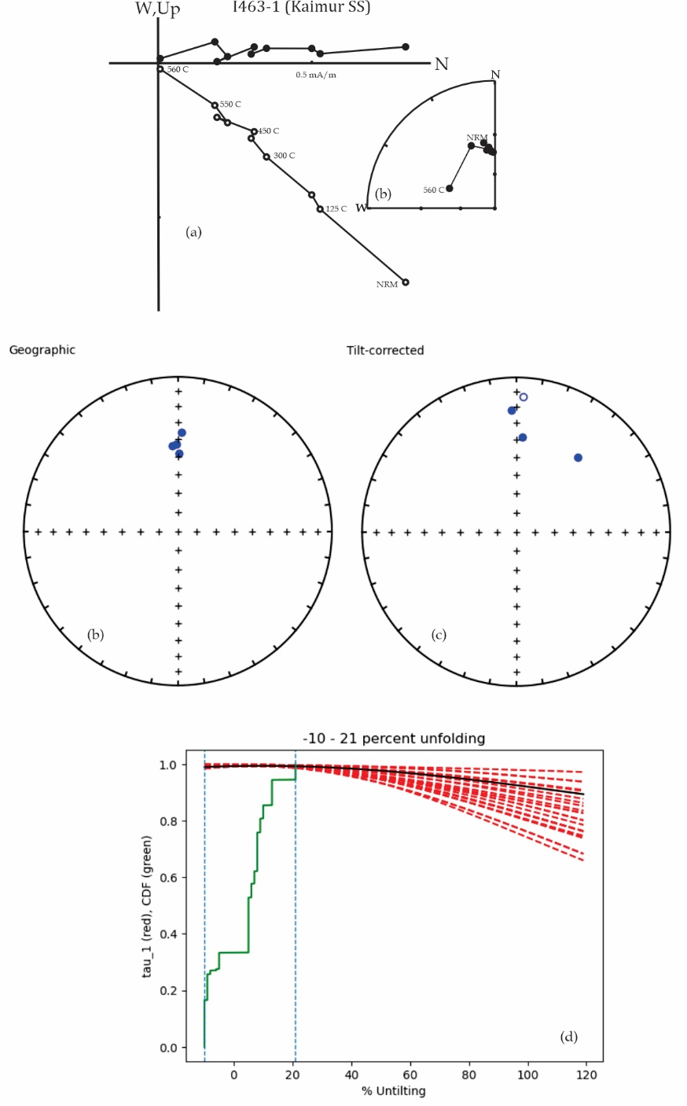
Supplementary Figure 3: (a) Typical demagnetization behavior for our Kaimur sandstone samples showing a northerly-shallow directed component of magnetization; (b) equal-area stereoplot of characteristic directions in geographic coordinates and (c) equal-area stereoplot of characteristics in tilt-corrected coordinates. (d) eigen-value negative fold test (Tauxe and Watson, 1994).

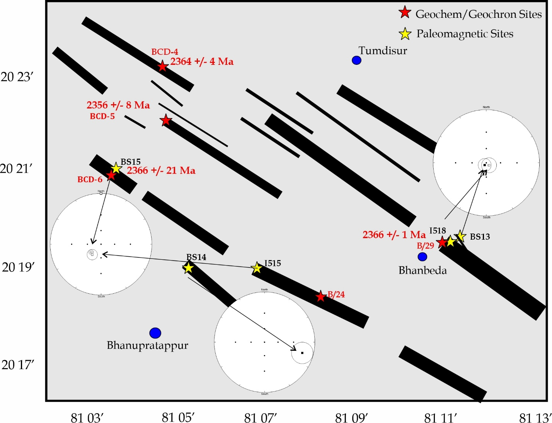
Supplementary Figure 5: Map of the Bhanupratappur area of the Bastar craton (see figure 10) where NW-trending dykes show directions consistent with 2.36, 2.25 and 1.88 Ga dykes rather than a single swarm.

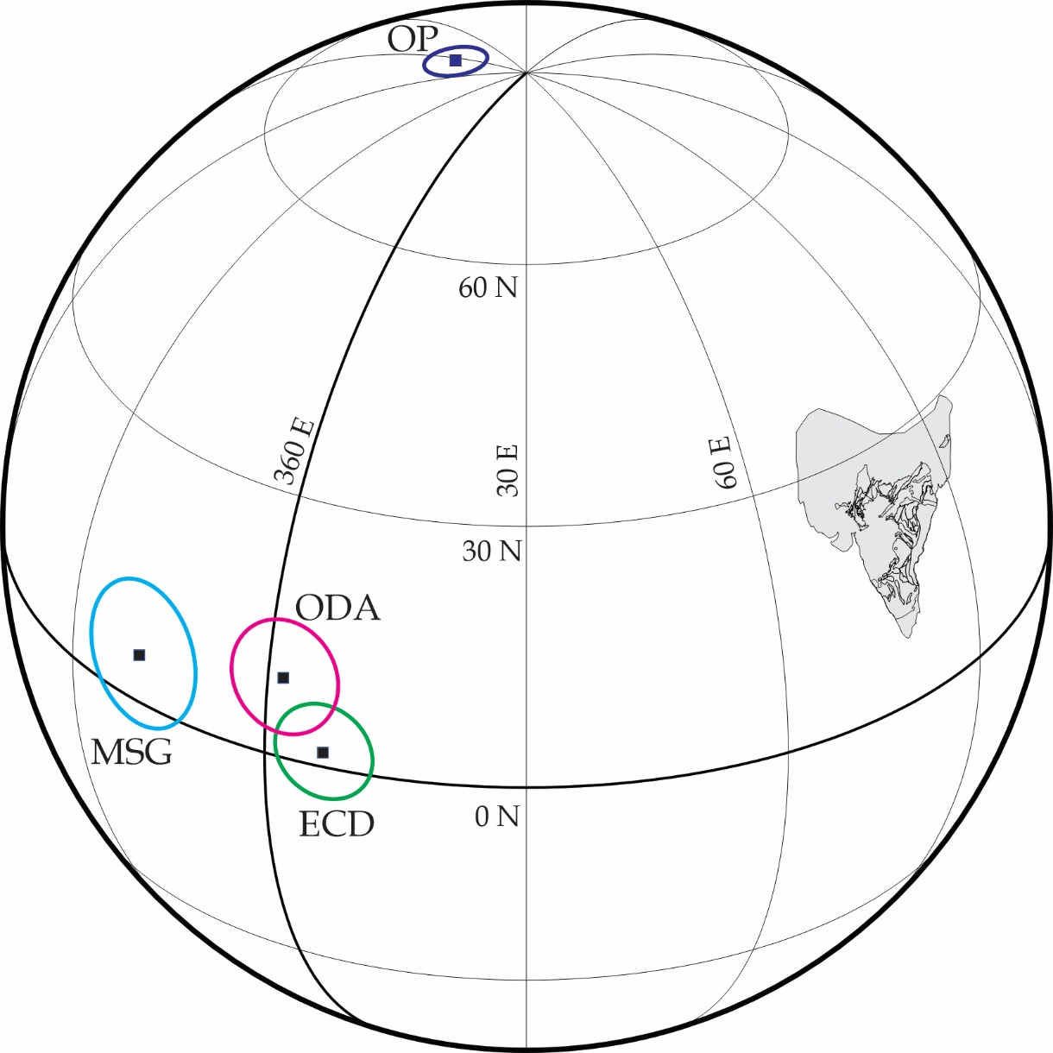
Supplementary Figure 6: Edicaran(?) poles and VGP’s from India. MSG=Marwar Supergroup; ODA=Oddanchantram Anorthosite; ECD=East Coast Dykes; OP=Overprint (Halls et al., 2007).

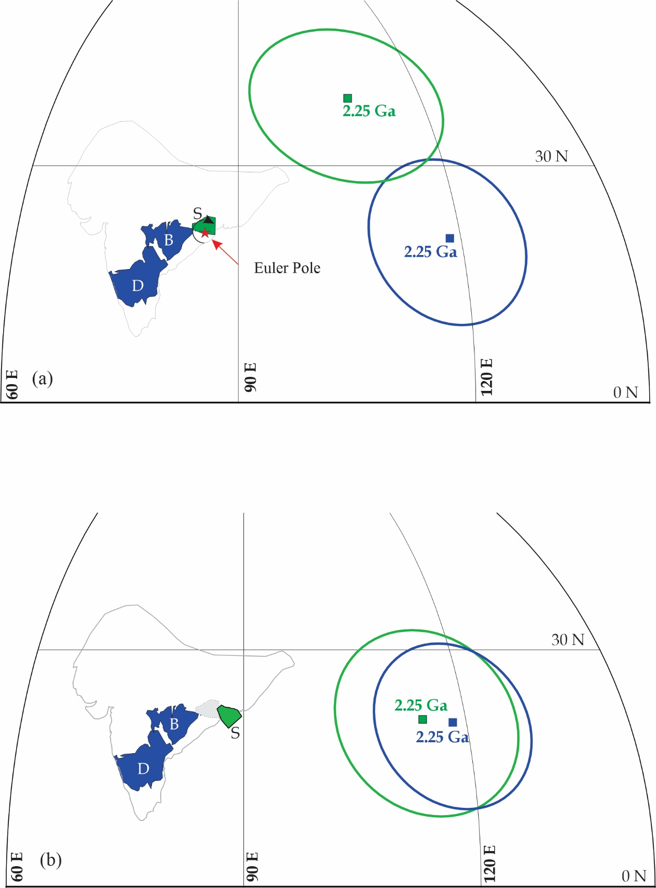
Supplementary Figure 7. (a) Paleomagnetic poles from the Dharwar (blue) and Singhbhum (green) cratons at 2.25 Ga according to the present-day disposition and (b) Singhbhum craton rotated about an Euler pole located near the southeastern terminus of the Mahanadi rift (21° N, 86.5° E, -46.5°).

